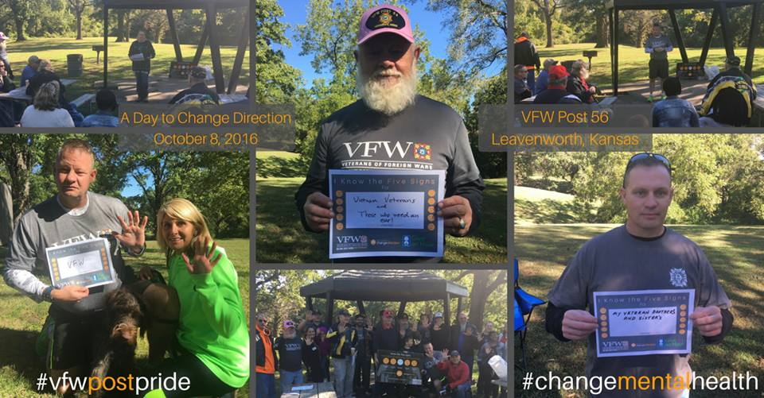
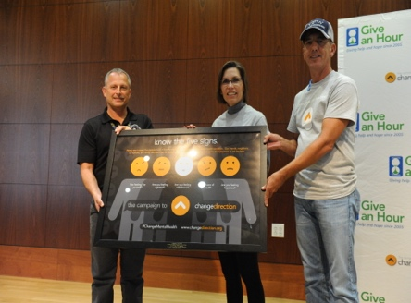
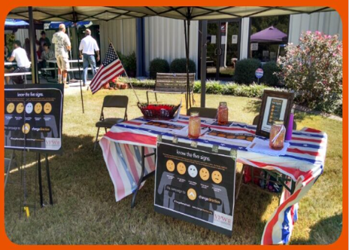
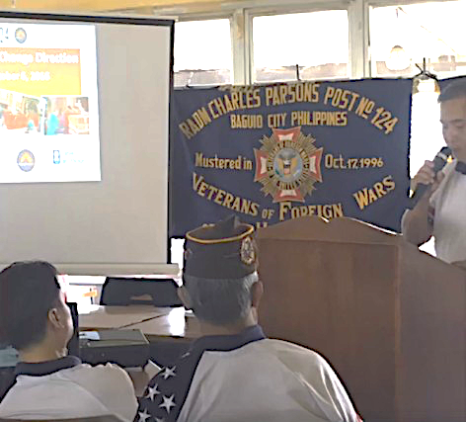
A Joint National Initiative

A Day to Change Direction
  - September 18th, 2021
Give an Hour and the VFW are partnering for the sixth annual A Day to Change Direction on September 18, 2021. This will be a national day of service, honored by the VFW and GAH, to promote dialogue on mental health, emotional suffering, and access to care, while striving to Change the Direction of mental health in America and around the world for everyone but for the veteran community in particular.
VFW Posts across the country will participate in this day of service by hosting activities in their local community while creating awareness of the Five Signs of Emotional Suffering and/or the Healthy Habits of Emotional Wellbeing.
Join Us
VFW Post (number) will be (activity) at (time) o’clock on September 18th. Please bring your (gear) and team spirit to join us at (location) to support this great cause.

